Module 3 - Our Global Village: Bridging Our Digital Divide
Introduction and Link to Ontario Catholic Graduate Expectations
As members of a Catholic school community, we are called to be responsible citizens. This means we witness Catholic social teachings by promoting equality, democracy, and solidarity for a just, peaceful, and compassionate society.
Teacher Instructions

- If your class has a SmartBoard, a projector, or if students have access to computers:
Visit several Catholic organizations and see how they are using social media to spread their message and connect with people.
Diosese of London http://wp.dol.ca/webportal/diocese/home/1
Pope Benedict on Twitter https://twitter.com/#!/popebenedictxiv

Development and Peace http://www.devp.org/en
Pope2You http://www.pope2you.net/index.php

Visit the Catholic Australian site Xt3.com

Open Source Catholic uses social media to share all things Catholic
See a great example in of a young person using social media (www.29leaps.com) for a good cause in Appendix 1 at the end of this document.

View the social media landscape in Appendix 2 to get ideas common types and uses of social media.
If you do not have access to the internet, ask students to identify how groups and organizations use social media to spread their message and connect with people.

- STUDENT TASK
Organize students into small groups. Provide each group with a copy of the student handout. (continued on next page)
If computers are available, provide each group with access to a computer.
Create a proposal outlining how social media tools could be used to:
- spread our gospel message
- promote a social justice cause
- raise awareness about a local or global issue
- engage youth in political action
- promote our school system and the Ontario Catholic Graduate Expectations
- Help others in need in your community
- Or another idea that your students come up with!

Students may consider using some of the social media tools found in the following image. The image is a link that will take you to the creator of the image. Notice that the social media tools identified in the image are all categorized according to their purpose.
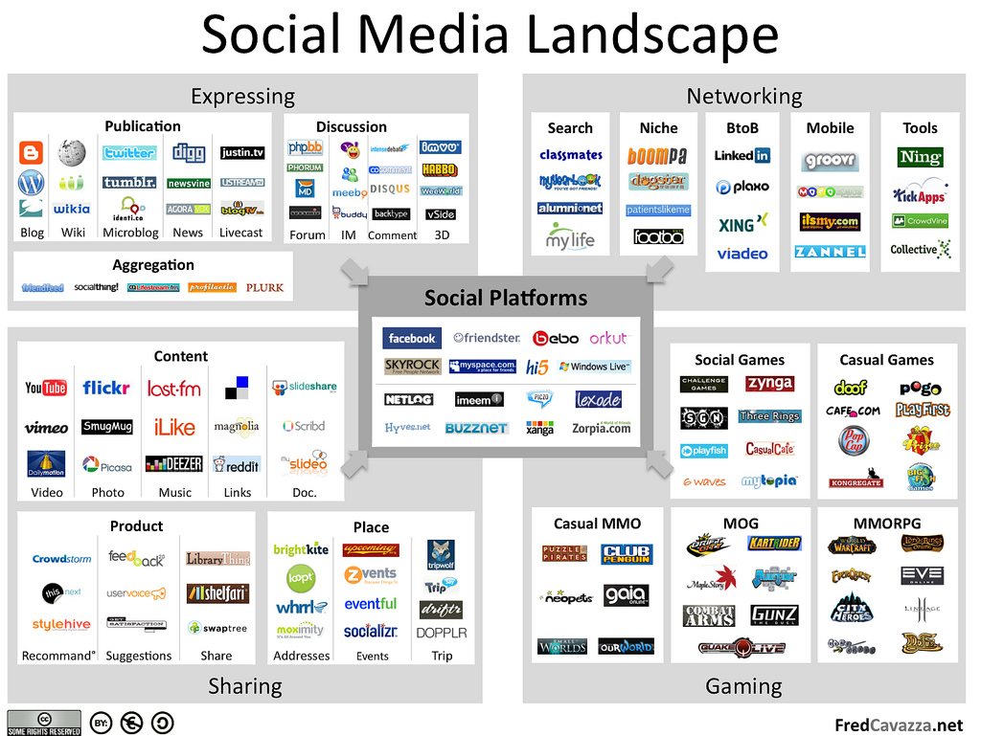

Group Sharing:
Have each group share their proposal with the class. Allow students to comment or ask questions about their plan. Consider challenging another class or arranging to share between classes.
Extension:
How would you evaluate the effectiveness of the use of the social media tools you have selected?
How do you know if your message is being heard?

Appendix 1

Example:
Read about the initiative called “29 Leaps”, started this year by a local teen.

Teen takes the leap to help others on Feb. 29
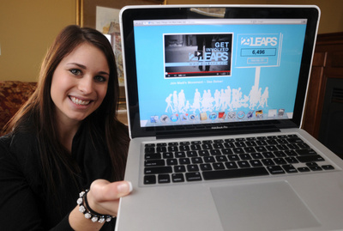
Taking the leap. Madi MacIntyre shows her website that encourages people to be philanthropic during the month of February. Mathew McCarthy/The RecordSource: The Record
By Ashley Csanady, Record staff
February 5, 2012
WILMOT TOWNSHIP — If you had an extra day, what would you do with it?
Go to the movies? Read? Shop?
That’s what Madi MacIntyre wants you to ask yourself as we get closer to February 29.
For some, an extra day in a leap year is another to spend with friends and family. But for the less fortunate, it could mean another day in a shelter or food bank line, or another day struggling to make it until payday.
So 17-year-old MacIntyre wants Canadians — and hopefully the world — to take 29 Leaps this February and pay it forward by donating 29 minutes of time, 29 dollars, 29 cans of food or 29 of whatever suits you best.
“It all started with the leap year ... but 29 is also a reasonable number,” she said.
The social media campaign and website (www.29leaps.com) launched the first day of February.
MacIntyre will find a way to donate 29 of something everyday for the rest of the month. On February 1, she gave $29 to three random guys on the street, challenging them to pay it forward. They did, buying Tim Hortons gift cards and passing them out to homeless people.
“We also want to get people to take the leap with us,” said the grade 11 student.
After just five days, more than 800 people have already jumped in online, and 29 “leaps” are added each time to the website’s growing tally, which is now over 24,000 and climbing. The goal is to help the campaign go viral, and get people around the world doing small good deeds throughout the month.
MacIntyre said the idea came to her in late January when she was discussing what to do with the extra day with her family and realized that not everyone would welcome an extra day.
Her dad, Jeff MacIntyre, set up a meeting with Echo Sims, a Kitchener-based social media and online marketing firm. The company threw itself behind the project, and offered its services for free. They shot a video the next day, and the site was live by Feb. 1.
She’s using sites like Facebook and Twitter to spread the word. And posts daily videos to YouTube, documenting her own 29 days of giving. She enjoys the social networking component the most.
“It’s a teenager’s life these days,” she said on Saturday as she sat in the kitchen of her family’s farmhouse near Petersburg.
And that’s helping her spread the word quickly and gain momentum. Her followers have already started campaigning celebrities like Ellen DeGeneres to spread the word and take the leap.
acsanady@therecord.com

Appendix 2
The following infographic shows all the various social media tools and platforms and how they interrelate. To learn more, visit the author’s website: http://www.fredcavazza.net/2010/12/14/social-media-landscape-2011/

Resources
Cast Your Net lessons and modules are based on the Catholic Curriculum Corporation’s two documents below:
Ethical and Responsible Use Of Information and Communication Technology: A Guideline for all Stakeholders in Catholic Education. November, 2009.
Ethical and Responsible Use of Information and Communication Technology Part II: K-6
Diosese of London http://wp.dol.ca/webportal/diocese/home/1
Pope Benedict on Twitter https://twitter.com/#!/popebenedictxiv
Development and Peace http://www.devp.org/en
Young person using social media for a good cause (www.29leaps.com)
The Social Media Landscape
Social Media for Social Good: A Tech Checklist for Non-profit Groups

Other Sites on Safety online
Rules ‘N Tools Checklist: for Parents, Educators, and Other Caring Adults. Implement both safety rules and software tools to protect children online. Focus on the positives of Internet use while teaching children about the dangers and how to make wise choices online.
Internet Safety 101 is a very detailed resource dedicated to making the internet safer for children. There are videos, quizzes, and resources for parents, teachers, & students.

